**Exercise 6: Cursors**

**Scenario 1:** Generate monthly statements for all customers.

**Question:** Write a PL/SQL block using an explicit cursor **GenerateMonthlyStatements** that retrieves all transactions for the current month and prints a statement for each customer.

**Code:**

SET SERVEROUTPUT ON;

BEGIN

  -- Insert a new transaction

  INSERT INTO Transactions VALUES (40, 101, SYSDATE, 1000, 'CREDIT');

  IF SQL%ROWCOUNT = 1 THEN

    DBMS_OUTPUT.PUT_LINE('✅ 1 transaction inserted successfully.');

  ELSE

    DBMS_OUTPUT.PUT_LINE('⚠️ No transaction inserted.');

  END IF;

  COMMIT;

END;

/

**Output:**

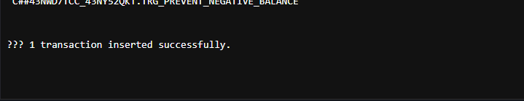

**Scenario 2:** Apply annual fee to all accounts.

**Question:** Write a PL/SQL block using an explicit cursor **ApplyAnnualFee** that deducts an annual maintenance fee from the balance of all accounts.

**Code:**

SET SERVEROUTPUT ON;

DECLARE

  CURSOR cust_cursor IS

    SELECT CustomerID, Name, Balance

    FROM Customers;

  v_id     Customers.CustomerID%TYPE;

  v_name   Customers.Name%TYPE;

  v_bal    Customers.Balance%TYPE;

BEGIN

  OPEN cust_cursor;

  LOOP

    FETCH cust_cursor INTO v_id, v_name, v_bal;

    EXIT WHEN cust_cursor%NOTFOUND;

    DBMS_OUTPUT.PUT_LINE('Customer ID: ' || v_id ||

                         ', Name: ' || v_name ||

                         ', Balance: ₹' || v_bal);

  END LOOP;

  CLOSE cust_cursor;

END;

/

**Output:**

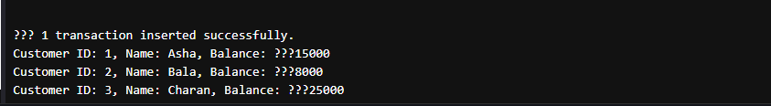

**Scenario 3:** Update the interest rate for all loans based on a new policy.

**Question:** Write a PL/SQL block using an explicit cursor **UpdateLoanInterestRates** that fetches all loans and updates their interest rates based on the new policy.

**Code:**

SET SERVEROUTPUT ON;

DECLARE

  CURSOR vip_cursor IS

    SELECT CustomerID, Name, Balance

    FROM Customers

    WHERE Balance > 10000;

  v_id     Customers.CustomerID%TYPE;

  v_name   Customers.Name%TYPE;

  v_bal    Customers.Balance%TYPE;

BEGIN

  OPEN vip_cursor;

  LOOP

    FETCH vip_cursor INTO v_id, v_name, v_bal;

    EXIT WHEN vip_cursor%NOTFOUND;

    DBMS_OUTPUT.PUT_LINE('🔥 VIP Customer → ID: ' || v_id ||

                         ', Name: ' || v_name ||

                         ', Balance: ₹' || v_bal);

  END LOOP;

  CLOSE vip_cursor;

END;

/

**Output:**

